**Trained YOLO11 Model Report**

**Model Summary**

The YOLO11 model was trained and validated with the following key metrics:

* **Total Layers**: 464
* **Parameters**: 25,344,847
* **Gradients**: 0 (indicating validation/inference stage)
* **Computational Complexity**: 86.9 GFLOPs

This model was evaluated using a dataset of 3,487 images, including 347 background images (no objects of interest) and no corrupt files.

**Validation Dataset**

* **Total Images**: 3,487
* **Backgrounds**: 347
* **Corrupt Files**: None

**Cache Issue**

The cache directory was not writable, and caching was not saved. This may impact validation speed in future runs.

**Detection Metrics**

**Overall Performance**

* **mAP50-95**: 59.5%
* **mAP50**: 66.2%
* **mAP75**: 61.3%

**Class-wise Metrics**

|  |  |  |  |  |
| --- | --- | --- | --- | --- |
| **Class** | **Precision** | **Recall** | **mAP50** | **mAP50-95** |
| **Person** | 0 | 0 | 0 | 0 |
| **Bicycle** | 0.802 | 0.844 | 0.883 | 0.804 |
| **Car** | 0.779 | 0.263 | 0.321 | 0.304 |
| **Motorcycle** | 0.964 | 0.787 | 0.818 | 0.785 |
| **Bus** | 0.214 | 0.526 | 0.234 | 0.194 |
| **Truck** | 0.645 | 0.654 | 0.654 | 0.570 |
| **JCB** | 0.907 | 0.754 | 0.878 | 0.771 |
| **Auto** | 0.913 | 0.766 | 0.909 | 0.807 |
| **Rickshaw** | 0.862 | 0.728 | 0.868 | 0.811 |
| **Cart** | 0.852 | 0.603 | 0.781 | 0.627 |
| **Scooter** | 0.908 | 0.809 | 0.936 | 0.875 |

**Observations and Insights**

**Strengths**

1. **High Performance for Specific Classes**:
   * "Scooter" (mAP50-95: 87.5%) and "Auto" (80.7%) achieved excellent performance, indicating robust detection for these objects.
   * "JCB" (77.1%) and "Rickshaw" (81.1%) also performed well.
2. **Generalized Detection**:
   * Overall mAP50-95 of 59.5% indicates the model has reasonable generalization capability across all classes.
3. **Efficient Inference**:
   * Average inference time per image is ~16.3 ms, suitable for real-time applications.

**Weaknesses**

1. **Poor Performance for "Person" and "Car":**
   * "Person" detection failed entirely (precision and recall of 0%).
   * "Car" had low recall (26.3%) and mAP50-95 (30.4%), likely due to insufficient or imbalanced training data.
2. **Low Performance for "Bus":**
   * Precision and recall for "Bus" were relatively low (21.4% and 52.6%, respectively), resulting in an mAP50-95 of 19.4%.
3. **Cache Directory Issue:**
   * Lack of caching may lead to slightly slower validation and inefficient resource utilization in future evaluations.

**Recommendations for Improvement**

**Data-related Improvements**

1. **Augment Data for Underperforming Classes:**
   * Collect and annotate more samples for "Person," "Car," and "Bus."
   * Use techniques like synthetic data generation or transfer learning to improve representation for these classes.
2. **Balance Dataset:**
   * Ensure a more even distribution of object classes in the training set.
3. **Fix Cache Directory Permissions:**
   * Resolve the cache directory issue to optimize validation speed and performance in subsequent runs.

**Model Optimization**

1. **Hyperparameter Tuning:**
   * Experiment with learning rates, augmentation strategies, and IoU thresholds to boost performance.
2. **Class Weights:**
   * Assign higher weights to underperforming classes to guide the model to focus on these during training.
3. **Fine-tuning:**
   * Use transfer learning with pre-trained models to improve detection for specific object classes.

**Performance Monitoring**

1. **Analyze Errors:**
   * Investigate false positives and false negatives for "Person," "Car," and "Bus" to identify and address specific challenges.
2. **Evaluate Across IoU Thresholds:**
   * Continuously monitor mAP scores at different IoU thresholds to understand performance trade-offs.

**Conclusion**

The YOLO11 model demonstrates good generalization with an overall mAP50-95 of 59.5% and efficient inference times suitable for real-time applications. However, there is significant room for improvement, particularly in detecting "Person," "Car," and "Bus" objects. Implementing the recommended changes can further enhance the model’s performance and reliability in deployment scenarios.

**Next Steps**

* Address data imbalances and augment datasets.
* Tune model hyperparameters and consider re-training.
* Resolve cache issues to improve validation efficiency.

**Result Interpretation :**

**1. Confusion Matrix (confusion_matrix.png and confusion_matrix_normalized.png)**

* **What it means**: The confusion matrix shows the counts of predicted vs. true labels for each class. The normalized version divides the counts by the total true instances of each class to show percentages.
* **Significance**: Helps evaluate the accuracy and class-wise performance of your model. It indicates where the model confuses certain classes.
* **Ideal shape**: The diagonal (top-left to bottom-right) should dominate with high values (close to 1 in normalized form), as it represents correct predictions.
* 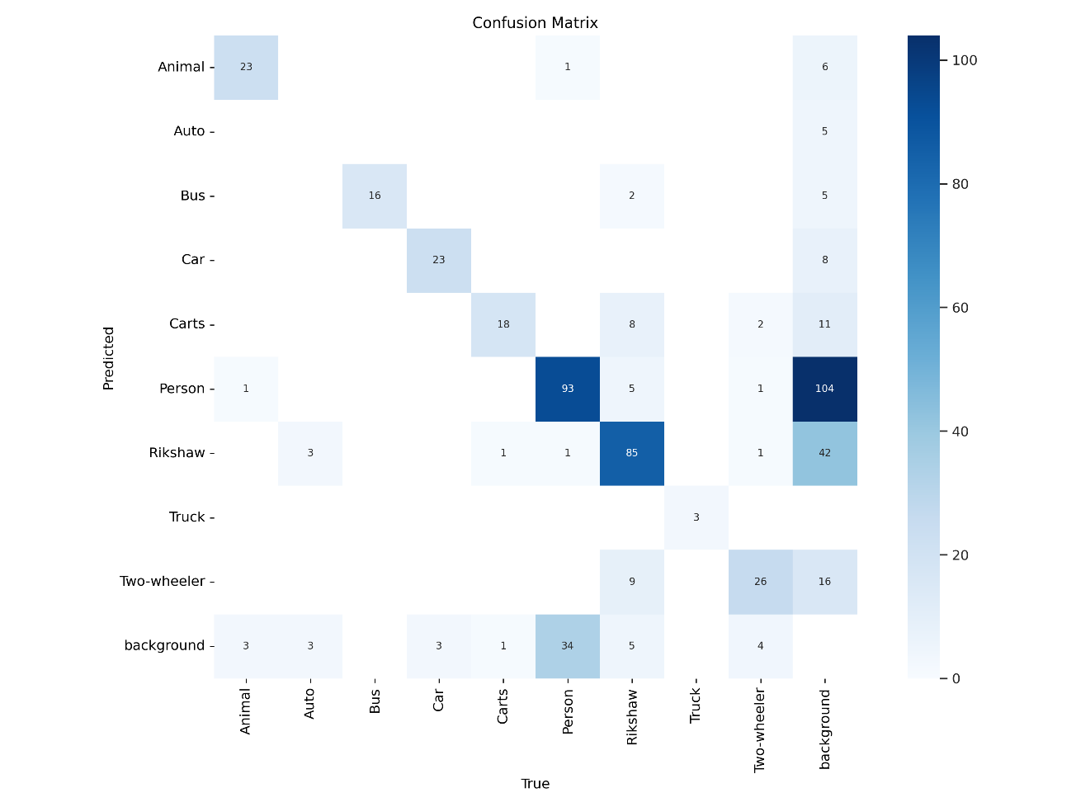**Output**:

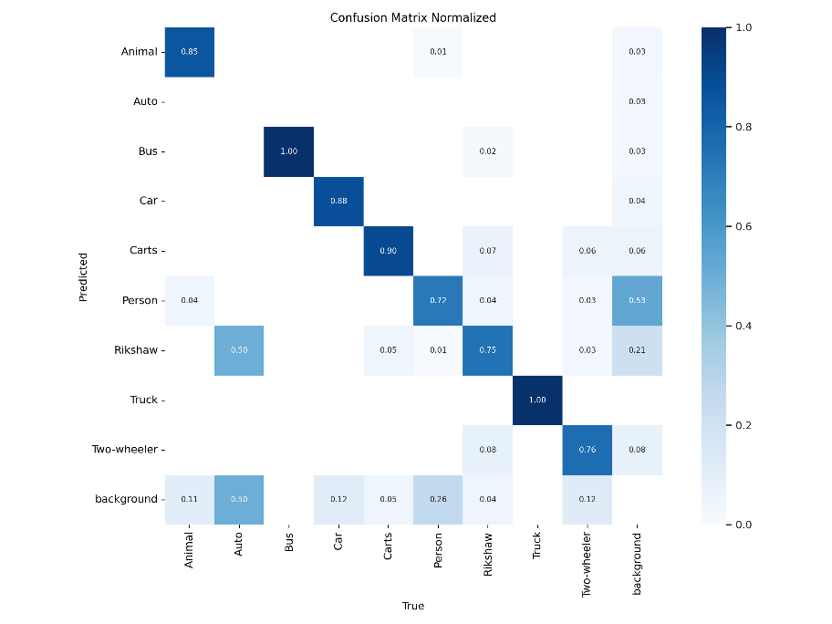

**2. F1 Curve (F1_Curve.png)**

* **What it means**: Shows the F1 score (a harmonic mean of Precision and Recall) at different confidence thresholds.
* **Significance**: Helps determine the confidence threshold that balances Precision and Recall for the best F1 score.
* **Ideal shape**: A curve that rises steeply and plateaus at a high F1 score. This indicates that the model performs well across a range of confidence thresholds.
* 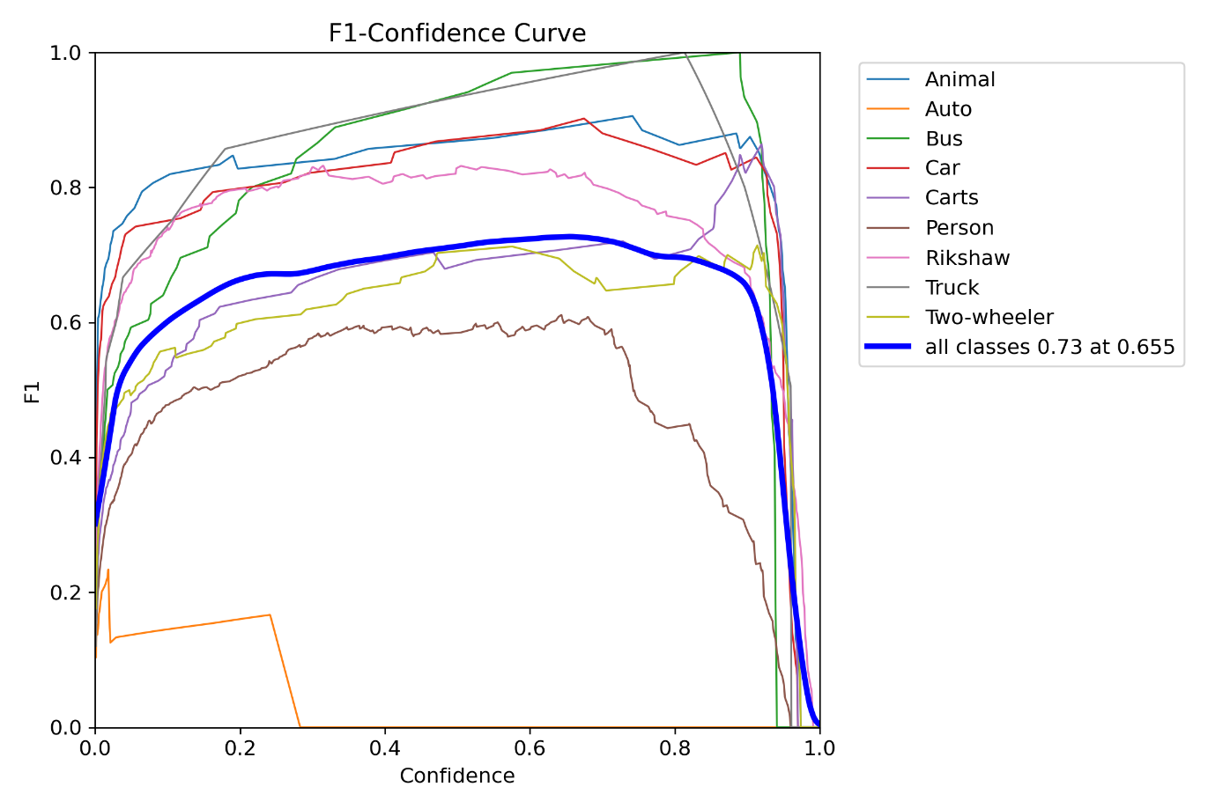**Output** :

**3. Labels (labels.jpg)**

* **What it means**: Contains multiple subplots:
  + **Instance Count Bar Graph**: Number of annotations per class.
  + **y vs x Scatter Plot**: Distribution of bounding box centers.
  + **Height vs Width Scatter Plot**: Distribution of bounding box sizes.
  + **Square Mesh Diagram**: Shows bounding box density in different spatial regions.
* **Significance**: Highlights the distribution of labels and spatial patterns in your dataset, helping identify class imbalance or annotation issues.
* **Ideal shape**:
  + Bar graph: Classes should have a similar count, avoiding imbalance.
  + Scatter plots: Even distribution without extreme outliers.
  + Square mesh: No extreme clustering in certain areas.
* **Output :**

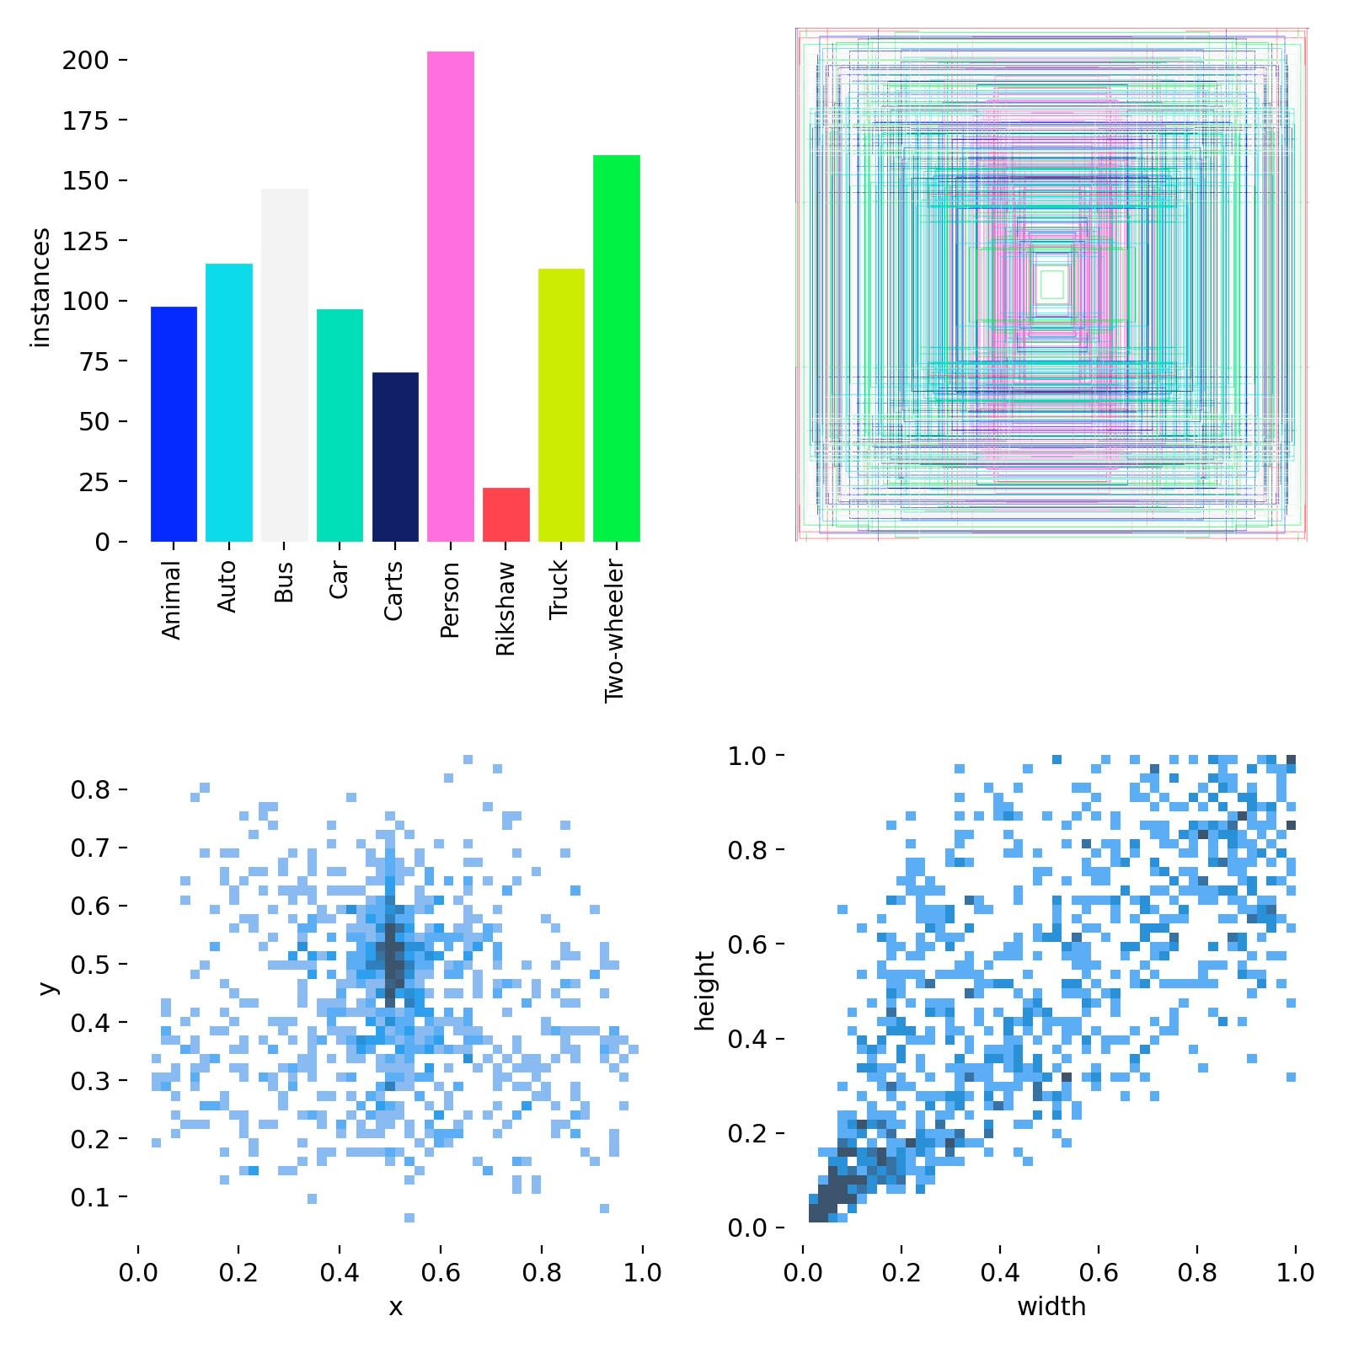

**4. Labels Correlogram (labels_correlogram.jpg)**

* **What it means**: Visualizes correlations between bounding box parameters (x, y, width, height).
* **Significance**: Helps identify relationships, e.g., whether larger objects are more likely to appear in certain regions.
* **Ideal shape**: Uniform correlations or distributions unless your dataset inherently has skewed characteristics.
* **Output** :

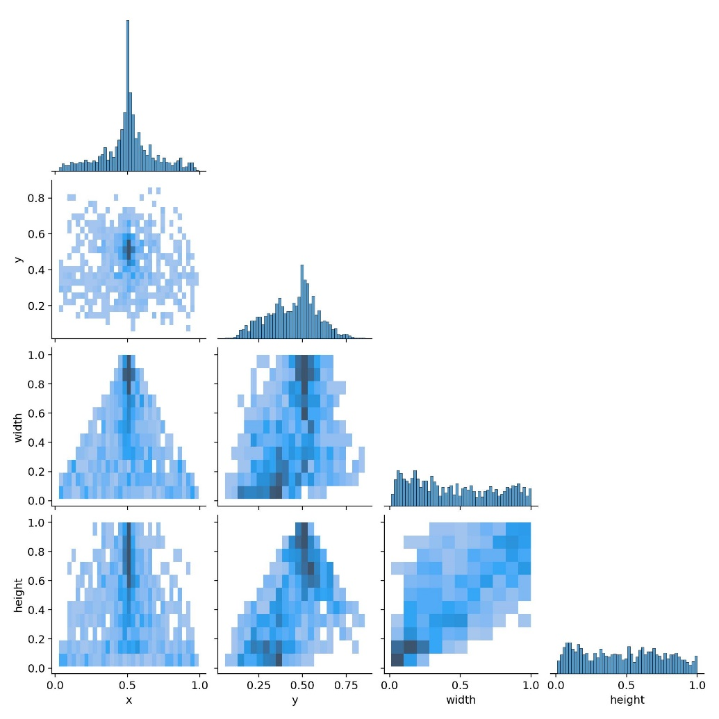

**5. Precision Curve (P_Curve.png)**

* **What it means**: Shows Precision at different confidence thresholds.
* **Significance**: Indicates the confidence threshold where the model starts making fewer false positives.
* **Ideal shape**: High Precision (close to 1) across a range of confidence thresholds.
* **Output** :

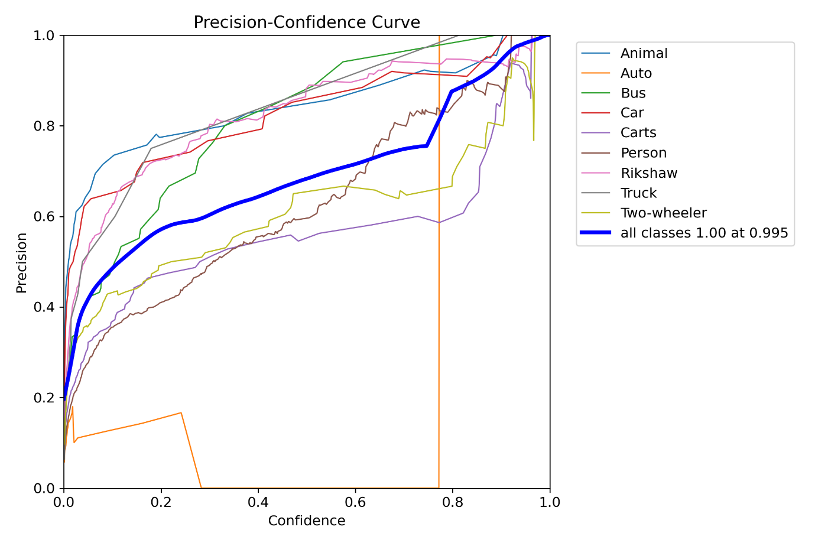

**6. PR Curve (PR_Curve.png)**

* **What it means**: Precision vs. Recall curve showing the trade-off between them.
* **Significance**: A higher area under this curve (closer to 1) indicates better performance.
* **Ideal shape**: A curve close to the top-right corner, indicating both high Precision and Recall.
* 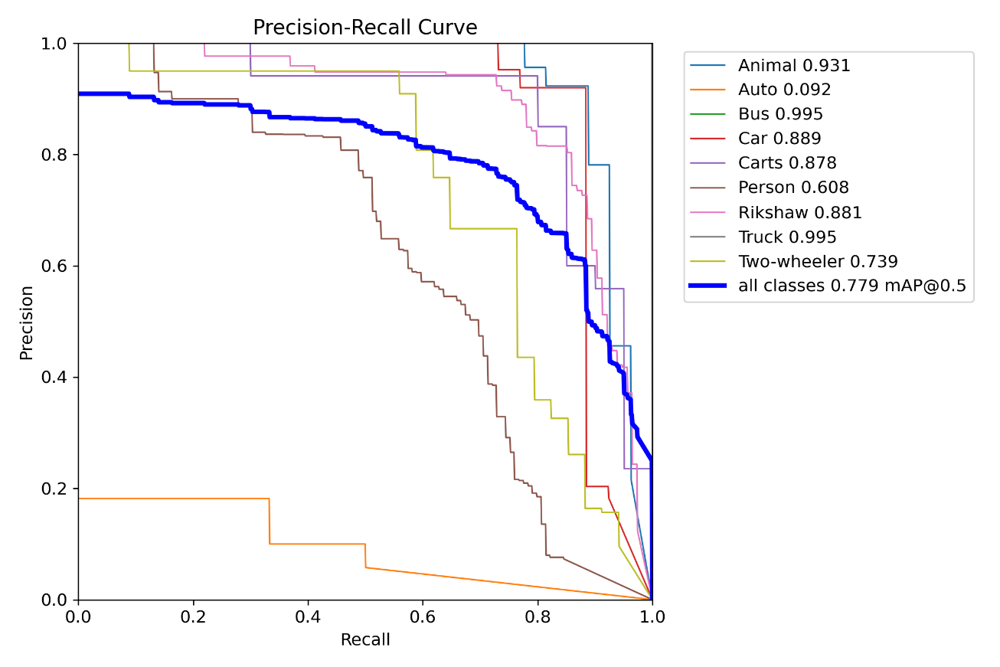**Output**:

**7. Recall Curve (R_Curve.png)**

* **What it means**: Shows Recall at different confidence thresholds.
* **Significance**: Indicates the threshold where the model starts missing fewer true positives.
* **Ideal shape**: High Recall (close to 1) across a range of thresholds.
* **Output**:

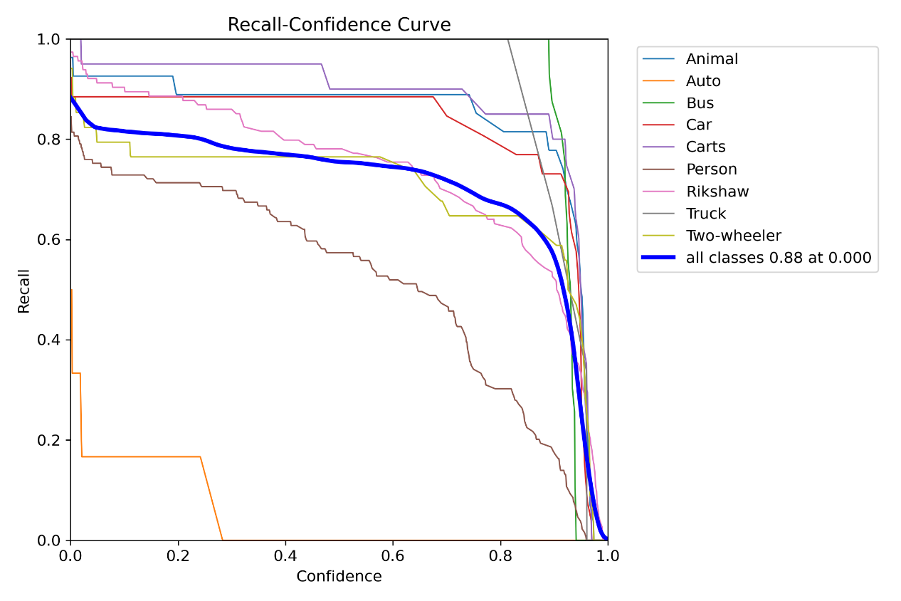

**8. Results (results.png)**

* **What it means**: Contains 10 charts showing training and validation losses and metrics.
  + **train/box_loss**: Loss related to bounding box predictions.
  + **train/cls_loss**: Loss related to classification predictions.
  + **train/dfl_loss**: Loss related to distributional focal loss.
  + **metrics/precision(B)**: Precision during training.
  + **metrics/recall(B)**: Recall during training.
  + **val/box_loss**, **val/cls_loss**, **val/dfl_loss**: Same losses evaluated on validation data.
  + **metrics/mAP50(B)**: Mean Average Precision at IoU=0.5.
  + **metrics/mAP50-95(B)**: Mean Average Precision across IoU thresholds 0.5 to 0.95.
* **Significance**: Shows the progress of training and validation. Decreasing losses and increasing metrics indicate improvement.
* **Ideal shape**:
  + Losses: Decreasing smoothly.
  + Metrics: Increasing and plateauing at high values.
* **Output:**

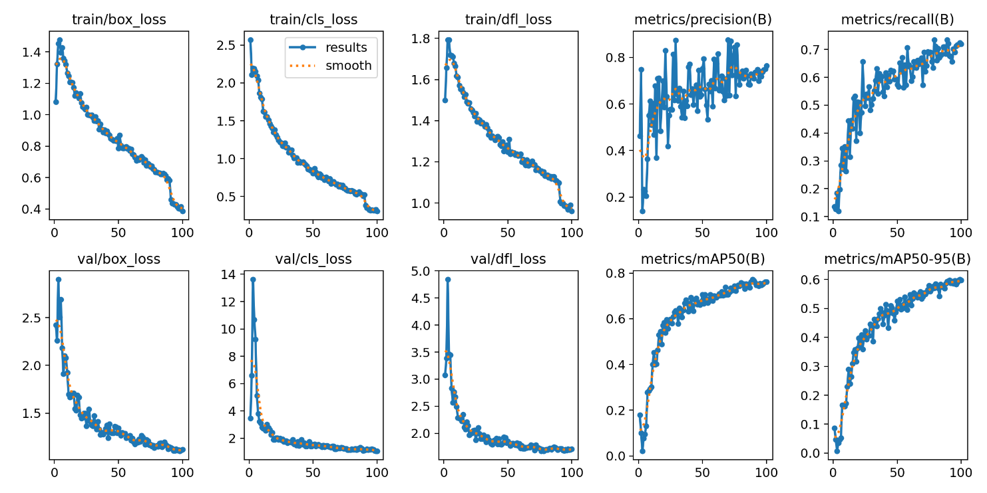

**9. *Train Batch Images (train_batch.jpg)*\***

* **What it means**: Shows training images with annotations.
* **Significance**: Verifies the data preprocessing and augmentation pipeline.
* **Ideal shape**: Clear and accurate bounding box annotations on all images.
* **Output**:

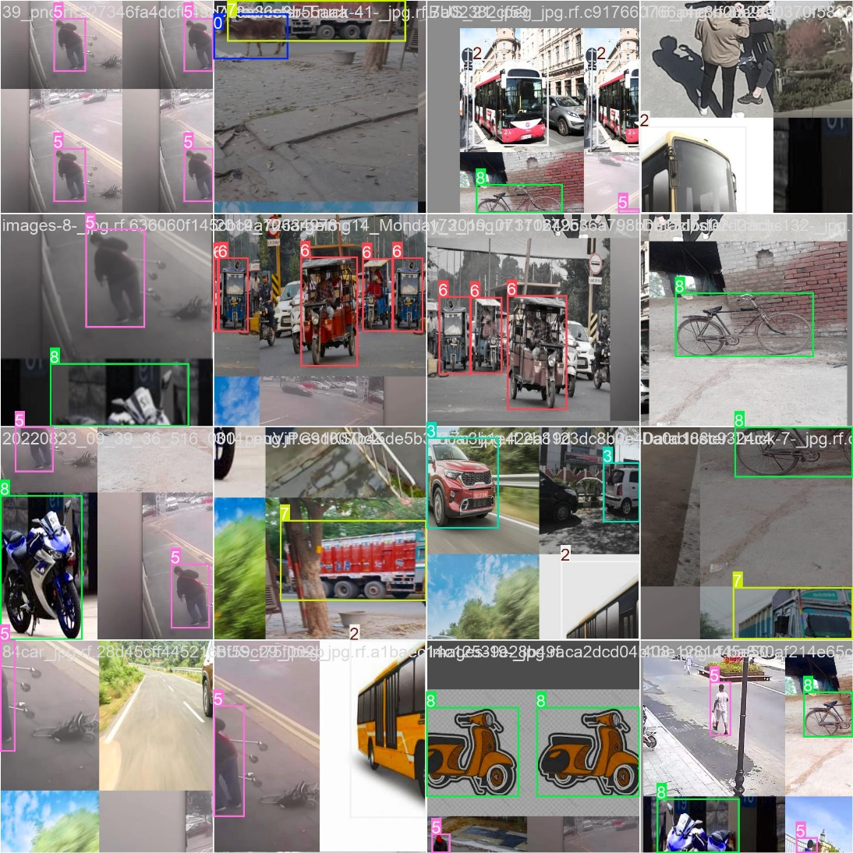

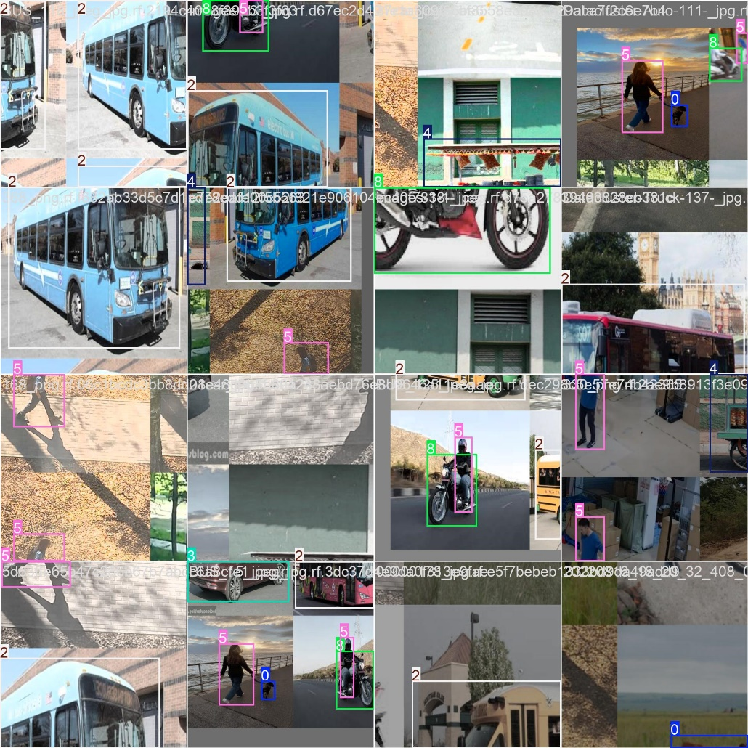

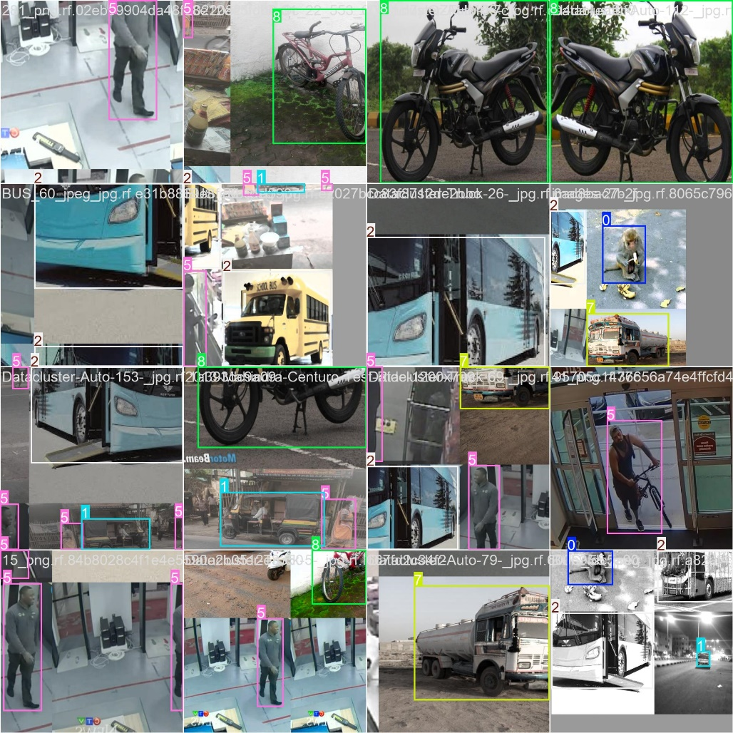

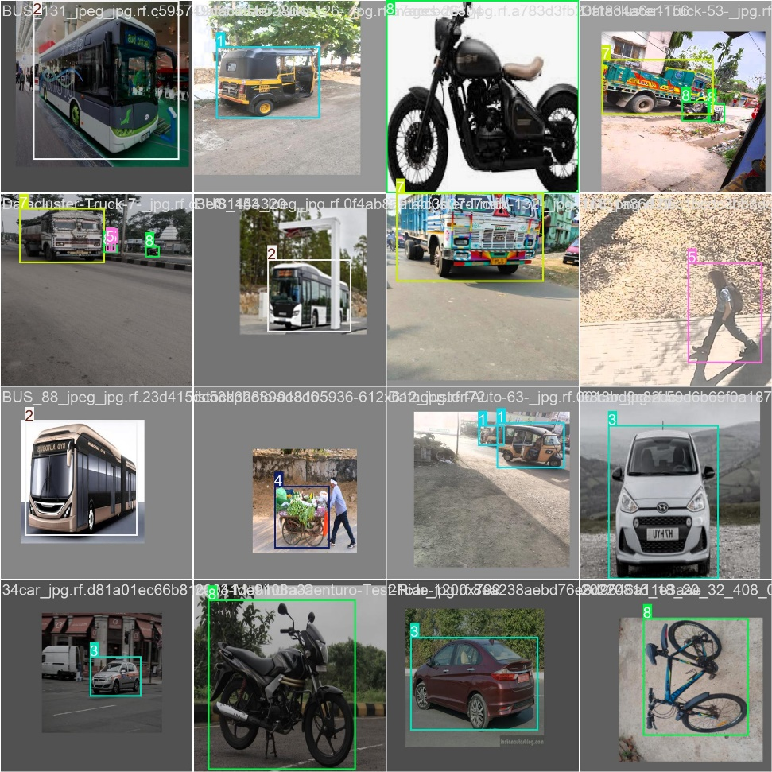

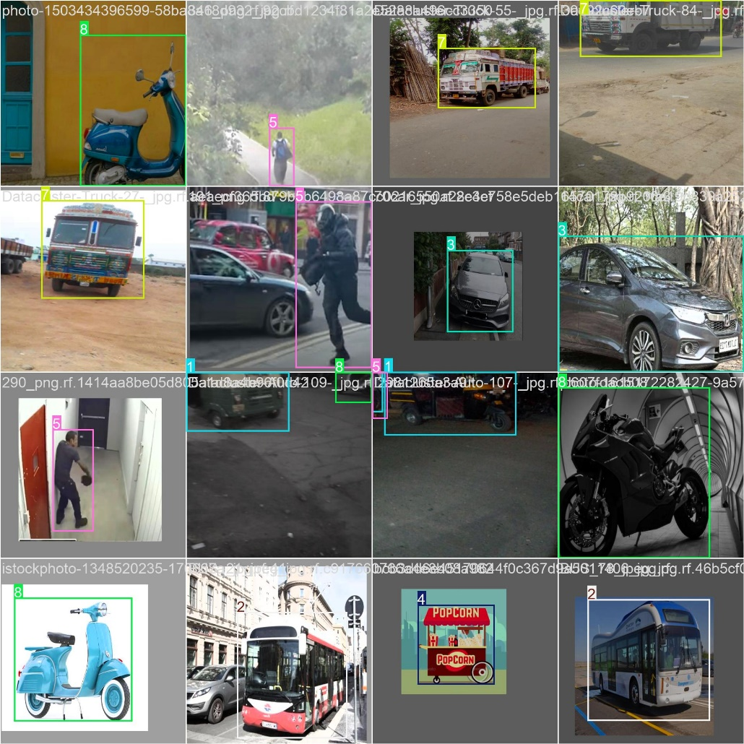

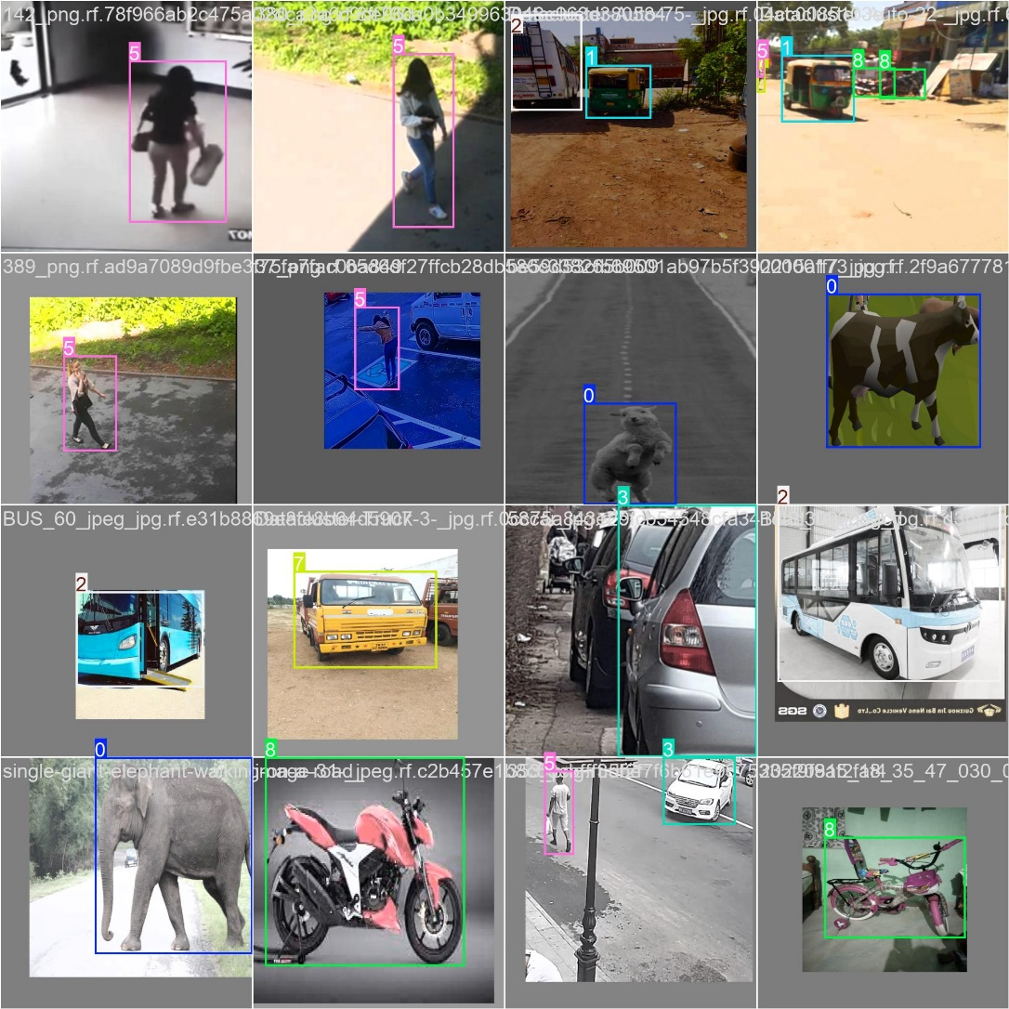

**10. Validation Batch Labels/Predictions (val_batch*_labels.jpg, val_batch*_pred.jpg)**

* **What it means**: Shows validation images with true labels (labels.jpg) and predicted labels (pred.jpg).
* **Significance**: Useful for qualitative analysis of the model's predictions.
* **Ideal shape**: Predicted bounding boxes should closely match true labels.
* **Output**:

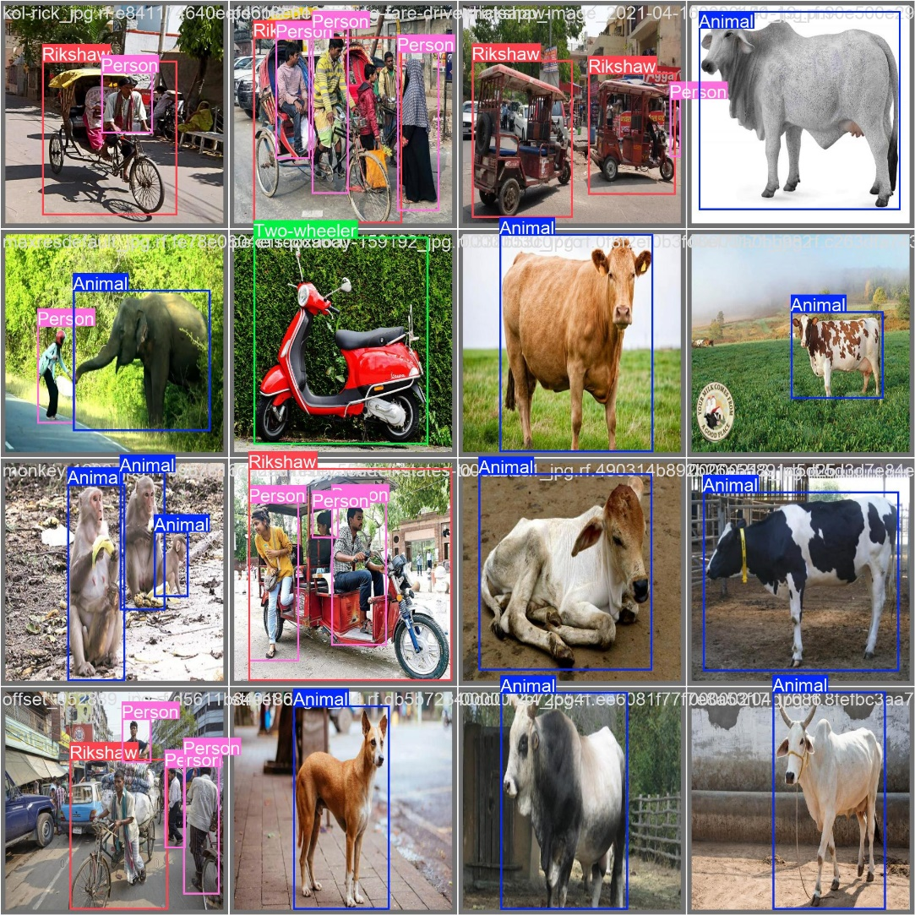

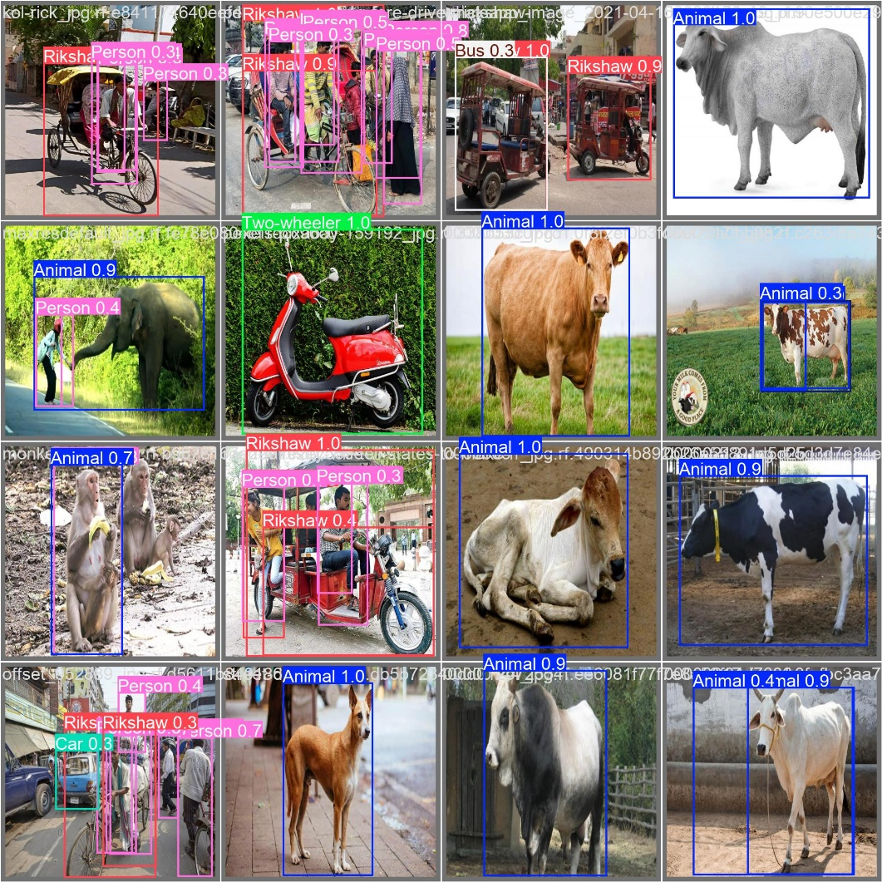

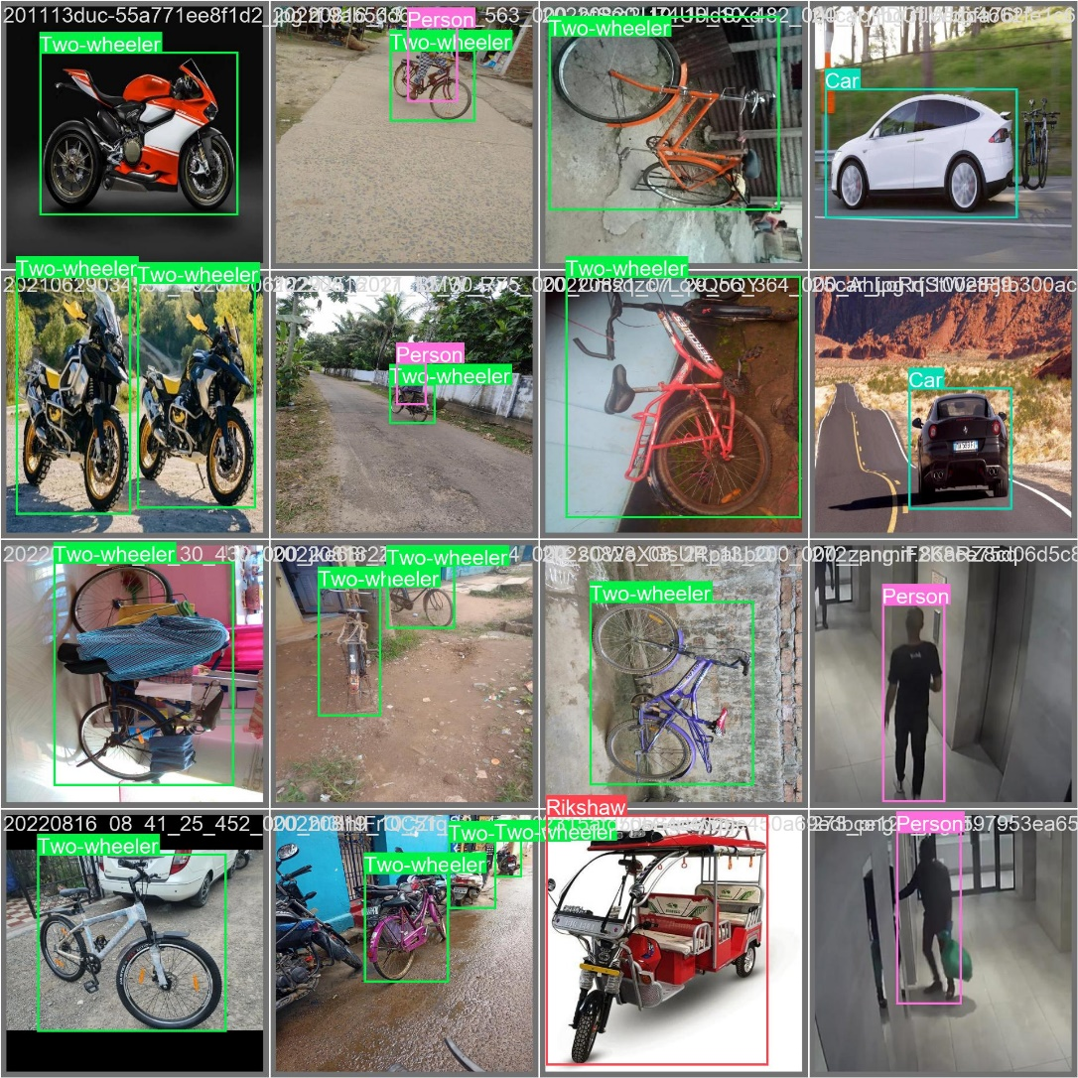

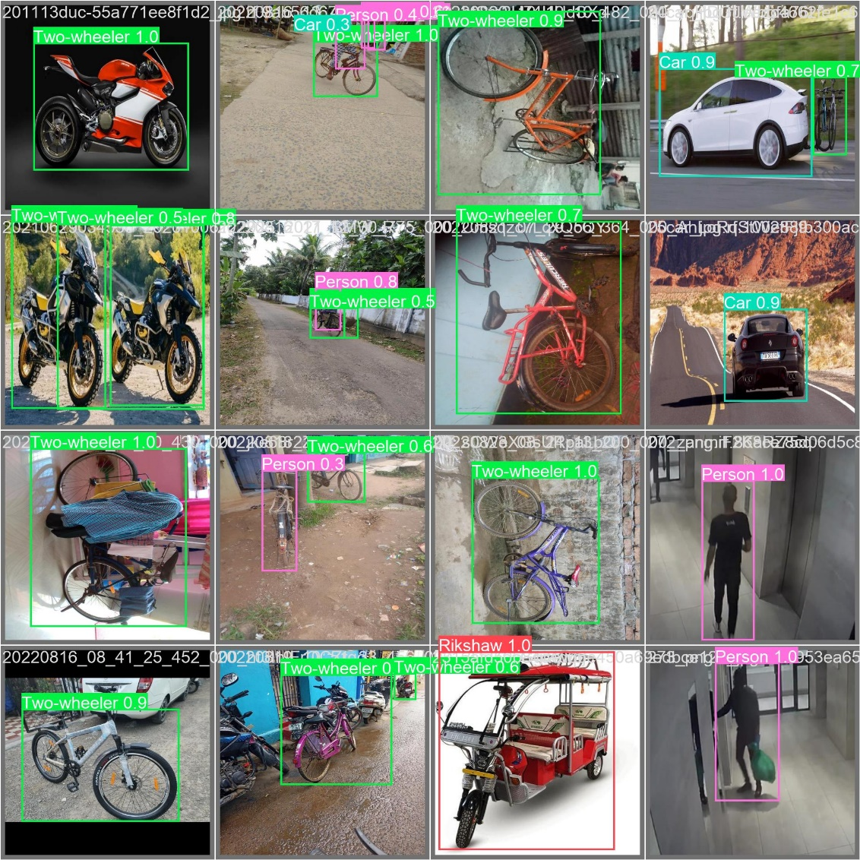

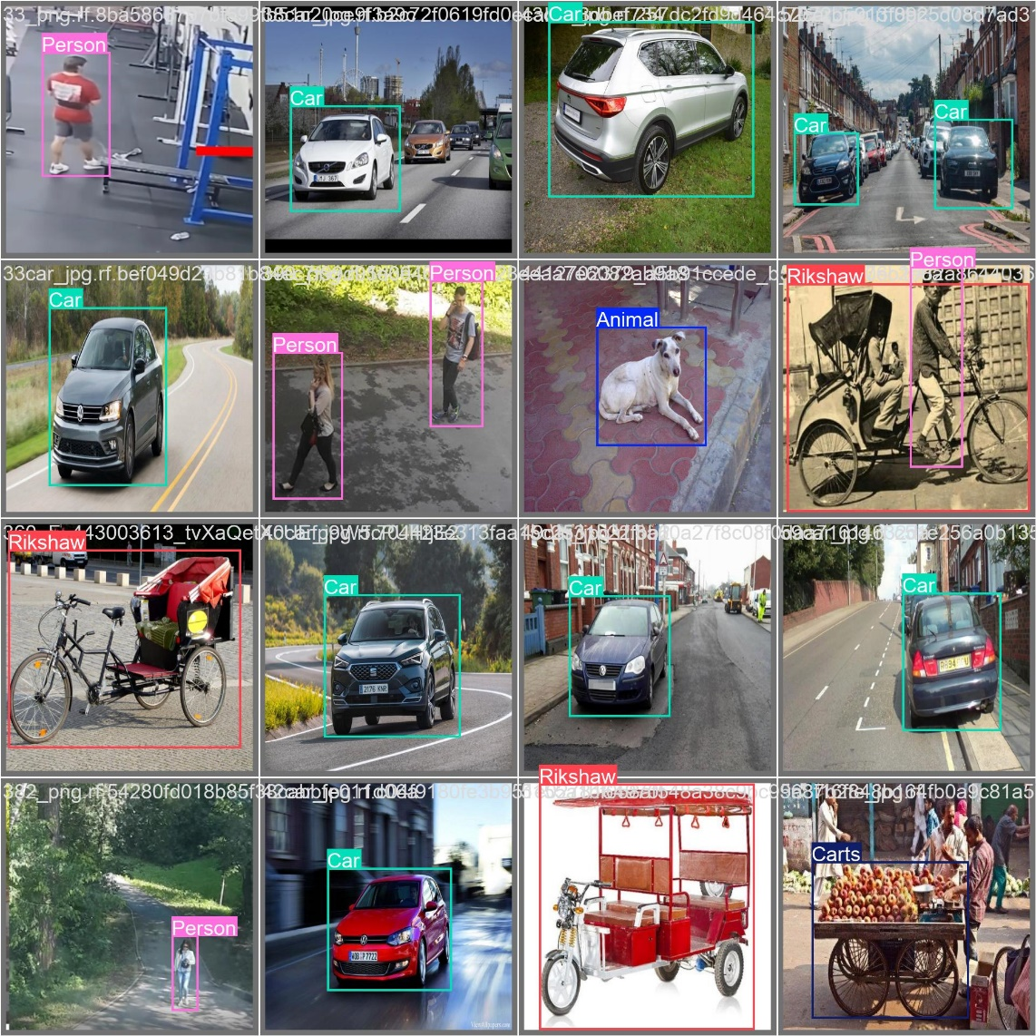

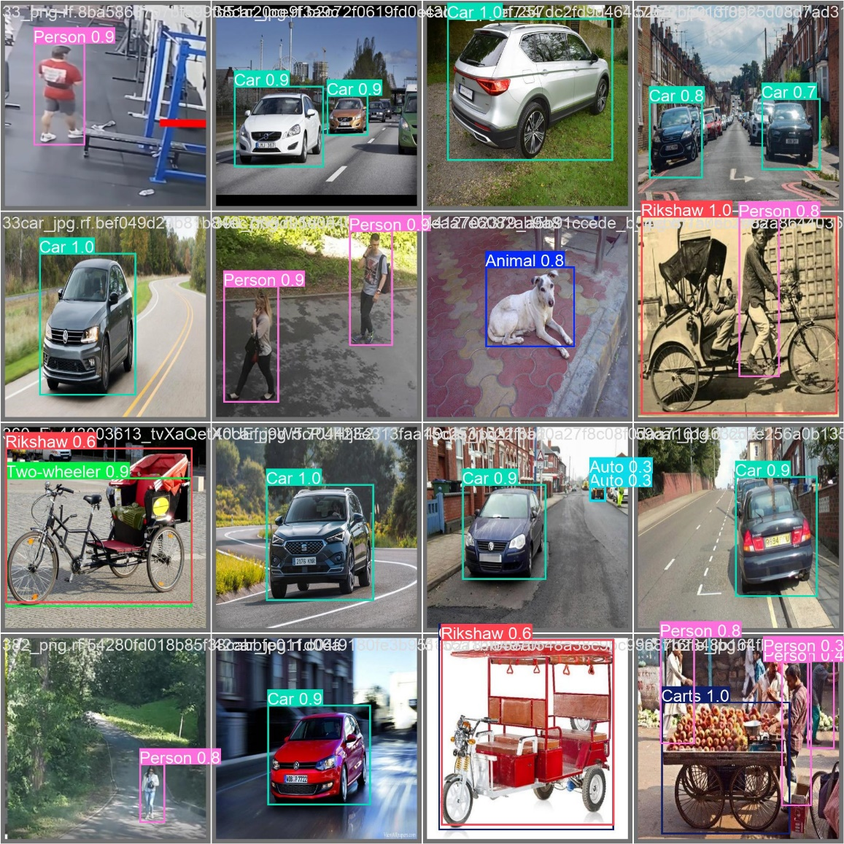

**11. Results CSV (results.csv)**

* **What it means**: Contains numerical data for each epoch (training progress).
* **Significance**: Useful for tracking and visualizing trends like losses decreasing and metrics improving over epochs.
* **Ideal shape**: Losses should decrease smoothly, and metrics should increase and plateau.
* **Output**:

**1. epoch**

* **Significance**: This column tracks the training progress by indicating the current epoch (i.e., an iteration through the entire training dataset). The value increases incrementally with each epoch, helping to understand how the model is performing as it sees more data over time.
* **Use**: This is useful for visualizing how the model's performance metrics (like loss and accuracy) evolve across different epochs of training.

**2. train/box_loss**

* **Significance**: The bounding box regression loss on the training data. This measures how well the model predicts the position and dimensions (coordinates) of bounding boxes for the detected objects. A lower loss indicates better accuracy in bounding box predictions.
* **Use**: A decreasing trend over epochs suggests that the model is improving its bounding box predictions as training progresses.

**3. train/cls_loss**

* **Significance**: The classification loss on the training data. This measures how well the model classifies detected objects into their correct categories (e.g., person, car, dog). Like bounding box loss, a lower classification loss means better classification accuracy.
* **Use**: A decreasing trend indicates that the model is learning to classify objects more accurately as training progresses.

**4. train/dfl_loss**

* **Significance**: The Distribution Focal Loss (DFL) used for bounding box regression. DFL is a specialized loss function that helps improve the quality of bounding box predictions by focusing on difficult or ambiguous examples. It adjusts the focus on harder-to-predict examples during training.
* **Use**: A decreasing value indicates that the model is improving its performance in fine-tuning bounding box predictions, especially for hard-to-predict cases.

**5. metrics/precision(B)**

* **Significance**: Precision measures how many of the predicted detections are actually correct (true positives) out of all the predictions made. It is a crucial metric to assess false positives.
* **Use**: Higher precision means fewer false positives. The trend over epochs can give insight into how the model is reducing false positives as it improves.

**6. metrics/recall(B)**

* **Significance**: Recall measures how many of the ground truth objects are correctly detected (true positives) out of all the actual objects in the dataset. It indicates how well the model is detecting objects and minimizing false negatives.
* **Use**: Higher recall means fewer false negatives. Tracking recall over epochs helps assess how the model is improving in detecting objects correctly.

**7. metrics/mAP50(B)**

* **Significance**: Mean Average Precision at an IoU (Intersection over Union) threshold of 0.5. This is a widely used metric in object detection that measures the overall precision of the model at IoU = 0.5. It combines both precision and recall into a single value, giving a holistic view of performance.
* **Use**: A higher mAP50 indicates better overall object detection performance at the 0.5 IoU threshold, which is considered a relatively lenient evaluation. This is often the first measure to assess model performance.

**8. metrics/mAP50-95(B)**

* **Significance**: Mean Average Precision averaged over multiple IoU thresholds, ranging from 0.5 to 0.95 (with a step of 0.05). This is a stricter evaluation metric, as it measures performance across multiple levels of overlap between the predicted and ground truth boxes.
* **Use**: Higher mAP50-95 indicates better performance across varying levels of object localization accuracy. This metric provides a more comprehensive view of detection quality, as it considers stricter conditions for a detection to be considered a true positive.

**9. val/box_loss**

* **Significance**: The bounding box loss on the validation set. This metric is similar to train/box_loss, but it is computed on a separate validation dataset that is not used for training. The validation loss helps evaluate how well the model generalizes to unseen data.
* **Use**: A decreasing val/box_loss indicates that the model is not only fitting well to the training data but is also performing well on the validation data.

**10. val/cls_loss**

* **Significance**: The classification loss on the validation set, measuring how accurately the model classifies objects in the validation data. Just like train/cls_loss, a lower value indicates better classification performance.
* **Use**: A decreasing val/cls_loss suggests that the model is generalizing well and becoming better at classifying objects in the validation set, not just the training data.

**11. val/dfl_loss**

* **Significance**: The Distribution Focal Loss on the validation set. It measures the accuracy of bounding box localization for the validation data, just as train/dfl_loss does for the training data.
* **Use**: A decrease in val/dfl_loss indicates that the model is improving its ability to localize bounding boxes accurately on unseen data.

**12. lr/pg0**

* **Significance**: Learning rate for parameter group 0, which generally refers to the initial layers or the backbone of the neural network. The learning rate controls the step size during the optimization process.
* **Use**: Tracking learning rates across different parameter groups helps to understand how the optimizer is adjusting the learning rate for different parts of the network. If the learning rate is too high, it might cause the model to converge too quickly or diverge. If it's too low, training might be slow.

**13. lr/pg1**

* **Significance**: Learning rate for parameter group 1, typically corresponding to later layers or specific components like the detection head of the model.
* **Use**: The learning rate for different parts of the model can be adjusted separately. This column allows you to monitor and fine-tune learning rates across various sections of the model to achieve better convergence.

**14. lr/pg2**

* **Significance**: Learning rate for parameter group 2, which could correspond to another specific part of the model (e.g., new layers or fine-tuned parameters).
* **Use**: Similar to lr/pg0 and lr/pg1, this learning rate can be adjusted to optimize training for specific layers or parts of the model. Tracking the learning rate for multiple groups allows for a more nuanced understanding of how different sections of the model are being trained.